# ASSIGNMENT 3

# Competitive Advantage in Real Companies

**Technology Sector: Microsoft Corporation :**

**INTRODUCTION : Founders**: Bill Gates and Paul Allen Founded: April 4, 1975 HQ: Redmond, Washington, United States CEO: Satya Nadella

**Key Products and Services:**

* **Operating Systems: Microsoft is widely recognized for its Windows operating system, which powers a significant portion of personal computers globally. Windows continues to evolve with updates and new versions catering to both consumer and enterprise needs.**
* **Productivity Software: Microsoft Office suite remains a cornerstone in the productivity software domain, offering applications like Word, Excel, PowerPoint, Outlook, and more. These tools are used extensively in businesses, educational institutions, and personal settings.**
* **Cloud Computing: Azure, Microsoft's cloud computing platform, is a major player in the rapidly growing cloud services market. Azure provides infrastructure as a service (IaaS), platform as a service (PaaS), and software as a service (SaaS) offerings to individuals and organizations.**
* **Enterprise Software: Microsoft offers a wide array of enterprise software solutions, including Dynamics 365 for customer relationship management (CRM) and enterprise resource planning (ERP), as well as various tools for collaboration, communication, and business intelligence.**
* **Hardware: Microsoft manufactures hardware products such as Surface tablets, laptops, and desktops, as well as accessories like keyboards, mice, and Surface Pens. Additionally, the company produces gaming consoles under the Xbox brand.**

Market Impact and Financial Performance:

Microsoft's influence extends across multiple sectors, including technology, business, education, and entertainment. With a market capitalization frequently exceeding $2 trillion, Microsoft is one of the largest publicly traded companies globally. Its consistent revenue growth and strong financial performance have made it a staple in investment portfolios and a benchmark for the technology sector**.**

Research competitive advantage :

* Brand Reputation: Microsoft enjoys a strong and reputable brand image globally. It has built this reputation over decades of providing reliable and innovative software, services, and hardware solutions to consumers, businesses, and governments.
* Product Differentiation: Microsoft's products stand out due to their advanced features, user-friendly interfaces, and compatibility across various platforms. For instance, the Windows operating system offers a wide range of functionalities catering to different user needs, while the Office suite remains the preferred choice for productivity software.
* Technological Innovation: Microsoft is known for its commitment to technological innovation. The company invests heavily in research and development (R&D) to stay ahead in areas such as artificial intelligence (AI), cloud computing, quantum computing, and augmented reality (AR) / virtual reality (VR).
* Market Leadership: Microsoft holds significant market leadership positions in several key segments. For instance, its Windows operating system dominates the PC market, while Office 365 leads the productivity software market. In cloud computing, Azure competes fiercely with other major players like Amazon Web Services (AWS) and Google Cloud Platform (GCP).
* Economies of Scale: Microsoft benefits from economies of scale due to its vast customer base and global operations. This allows the company to spread its fixed costs over a larger output, resulting in lower average costs per unit and increased profitability.
* Distribution Network: Microsoft has an extensive distribution network comprising direct sales, retail partners, and online platforms. This network ensures widespread availability of its products and services, reaching customers in diverse geographical locations and market segments.
* Integration and Synergy: Microsoft's ecosystem of products and services offers seamless integration and synergy, enhancing the overall user experience and driving customer loyalty. For example, compatibility between Windows, Office, and Azure facilitates smooth workflow transitions for users across different devices and platforms.
* Strong Financial Position: With a robust balance sheet and steady revenue growth, Microsoft enjoys a strong financial position. This stability enables the company to weather market fluctuations, invest in future initiatives, and pursue strategic acquisitions to further strengthen its competitive position

FINANCIAL PERFORMANCE :

Revenue Growth: Microsoft has experienced steady revenue growth over the years, driven by its diverse product portfolio and expanding cloud computing business. Its revenue streams come from various segments, including productivity and business processes, intelligent cloud, and more personal computing.

Cloud Computing Growth: Microsoft's cloud computing platform, Azure, has been a significant contributor to its revenue growth. Azure competes with other major cloud service providers like Amazon Web Services (AWS) and Google Cloud Platform (GCP). Microsoft's focus on expanding its cloud services and infrastructure has resulted in substantial revenue gains in this segment.

Profitability: Microsoft has maintained healthy profit margins, reflecting its ability to efficiently monetize its products and services. The company's operating income and net income have shown consistent growth over the years, driven by revenue expansion and effective cost management strategies.

Cash Flow Generation: Microsoft generates significant cash flows from its operations, allowing it to reinvest in business expansion, research and development, strategic acquisitions, and returning value to shareholders through dividends and share buybacks. Strong cash flow generation indicates the company's financial strength and ability to sustain its growth initiatives.

Balance Sheet Strength: Microsoft maintains a robust balance sheet with ample liquidity and manageable levels of debt. Its financial stability provides flexibility in pursuing growth opportunities and navigating economic uncertainties.

Market Capitalization: Microsoft is one of the most valuable publicly traded companies globally, with a market capitalization frequently exceeding $2 trillion. Its strong financial performance and growth prospects have contributed to its high market valuation, making it a cornerstone in investment portfolios.

Dividend Payments: Microsoft has a history of consistently paying dividends to its shareholders. The company's dividend yield and payout ratio are reflective of its commitment to returning value to investors while retaining sufficient capital for growth initiatives.

Distribution Network: Microsoft has an extensive distribution network comprising direct sales, retail partners, and online platforms. This network ensures widespread availability of its products and services, reaching customers in diverse geographical locations and market segments.

Integration and Synergy: Microsoft's ecosystem of products and services offers seamless integration and synergy, enhancing the overall user experience and driving customer loyalty. For example, compatibility between Windows, Office, and Azure facilitates smooth workflow transitions for users across different devices and platforms.

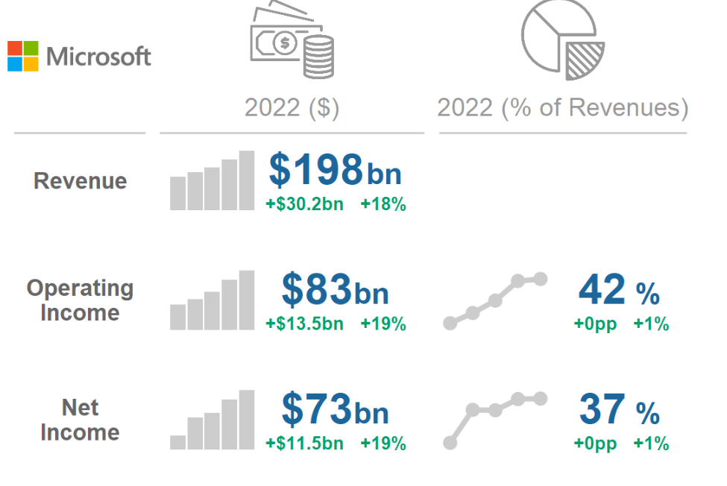

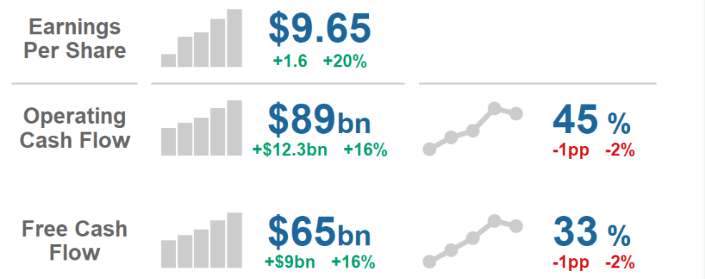

MICROSOFT CORPORATIONS COMPITATIVE ADVANTAGE TO THE FINANCIAL SUCCESS :

Diversified Product Portfolio: Microsoft offers a wide range of products and services spanning operating systems, productivity software, cloud computing, gaming, hardware, and more. This diversification not only mitigates risks associated with dependence on a single product but also allows Microsoft to capture revenue from various sources, driving overall financial performance.

Strong Brand Recognition: Microsoft's brand is globally recognized and trusted. Its reputation for quality, reliability, and innovation enhances customer loyalty and attracts new users. This brand strength enables Microsoft to command premium pricing for its products and services, contributing to higher revenues and profitability.

Technological Innovation: Microsoft has a long history of innovation, continually introducing new technologies and enhancing existing products. Investments in research and development (R&D) enable the company to stay ahead of competitors and address evolving customer needs. Innovations like Azure cloud services, Office 365, and Surface devices have not only driven revenue growth but also positioned Microsoft as a leader in key technology segments.

Market Leadership: Microsoft holds leading positions in several markets, including operating systems, productivity software, and cloud computing. Its dominance in these areas provides a competitive advantage by solidifying customer relationships, attracting developers, and establishing network effects that further strengthen its market position.

Economies of Scale: As one of the largest technology companies globally, Microsoft benefits from economies of scale in production, distribution, and marketing. The company's vast customer base and global reach enable it to spread fixed costs over a large volume of sales, resulting in lower average costs per unit and higher profitability.

Cloud Computing Dominance: Microsoft's Azure cloud platform is a significant driver of its financial success. Azure's rapid growth and adoption have positioned Microsoft as a leading player in the cloud computing market, competing effectively with industry giants like Amazon Web Services (AWS). The recurring revenue model of cloud services contributes to revenue stability and long-term growth prospects.

Strategic Acquisitions: Microsoft has a history of strategic acquisitions that complement its existing business and expand its capabilities. Acquisitions such as LinkedIn, GitHub, and Nuance Communications have not only added new revenue streams but also enhanced Microsoft's competitive position in areas like professional networking, developer tools, and healthcare technology.

Customer Relationships: Microsoft's strong relationships with enterprise customers, small businesses, educational institutions, and individual consumers provide a competitive advantage. These relationships foster customer loyalty, drive recurring revenue through subscription-based services, and create opportunities for upselling and cross-selling additional products and services.

**Consumer Goods Sector: The Procter & Gamble Company :**

Founders: William Procter and James Gamble

Founded: 1837

HQ: Cincinnati, Ohio, United States

CEO: David S. Taylor

Product Portfolio:

P&G offers a vast array of brands across various categories, catering to the everyday needs of consumers. Some of its well-known brands include:

Home Care: Brands like Tide, Dawn, Cascade, and Febreze offer solutions for laundry, dishwashing, and household cleaning.

Personal Care: P&G's personal care segment includes brands such as Pantene, Head & Shoulders, Gillette, Olay, Crest, Oral-B, and Old Spice, covering products for hair care, skincare, oral care, and grooming.

Baby Care: Pampers, one of P&G's flagship brands, is a global leader in the baby care category, offering diapers, wipes, and related products.

Healthcare: P&G's healthcare brands include Vicks, Always, and Metamucil, providing solutions for cough and cold relief, feminine hygiene, and digestive health.

Feminine Care: Brands like Always and Tampax offer a range of feminine hygiene products, including pads, liners, and tampons.

Market Impact and Global Presence:

P&G's products are household names in many countries around the world. The company's extensive distribution network ensures that its products are readily available to consumers across various regions and demographics. P&G's global footprint and market leadership positions in several consumer goods categories underscore its significant impact on the consumer goods sector.

Innovation and Sustainability:

P&G emphasizes innovation to meet evolving consumer preferences and sustainability goals. The company invests in research and development to develop new products, improve existing formulations, and reduce environmental impacts. Initiatives such as lightweight packaging, water conservation efforts, and renewable energy investments demonstrate P&G's commitment to sustainability and corporate responsibility.

Financial Performance:

P&G has a track record of strong financial performance, characterized by consistent revenue growth, healthy profit margins, and strong cash flow generation. The company's ability to adapt to changing market conditions, invest in brand building and innovation, and efficiently manage costs has contributed to its financial success and long-term shareholder value creation.

RESEARCH AND COMPITATIVE ADVANTAGE OF P&G :

P&G invests significantly in research and development to innovate and improve its products. This investment enables the company to stay ahead of competitors, address consumer needs, and introduce new technologies and formulations.

Research efforts focus on areas such as product efficacy, sustainability, safety, and consumer insights to create products that resonate with customers and maintain market relevance.

Brand Portfolio:

P&G boasts a diverse and extensive portfolio of well-established brands, covering multiple consumer goods categories. Brands like Tide, Pampers, Gillette, and Crest are household names with strong brand recognition and consumer loyalty.

The breadth and depth of P&G's brand portfolio provide the company with a competitive advantage by capturing a significant share of consumer spending across various product categories.

Innovation and Product Differentiation:

P&G is committed to continuous innovation to differentiate its products from competitors and meet evolving consumer preferences. The company introduces new features, formulations, and packaging innovations to enhance product performance and appeal.

Innovation extends beyond product development to areas such as marketing strategies, distribution channels, and customer engagement, enabling P&G to maintain a competitive edge in the marketplace.

Global Presence and Distribution Network:

P&G's extensive global presence and distribution network give it a competitive advantage in reaching consumers worldwide. The company operates in over 180 countries, leveraging its expansive network of manufacturing facilities, distribution centers, and retail partnerships.

This widespread presence enables P&G to respond quickly to market trends, adapt to local preferences, and capitalize on emerging opportunities in diverse geographical regions.

Cost Efficiency and Scale:

P&G benefits from economies of scale due to its large-scale production capabilities and global operations. The company's size allows it to achieve cost efficiencies in sourcing, manufacturing, and distribution, contributing to competitive pricing and profitability.

Scale also provides P&G with bargaining power with suppliers, retailers, and other partners, further enhancing its competitive position in the consumer goods industry.

Marketing and Advertising Capabilities:

P&G is renowned for its marketing and advertising prowess, investing heavily in branding, advertising campaigns, and consumer engagement initiatives. The company's marketing efforts effectively communicate brand messages, build brand equity, and drive consumer awareness and loyalty.

P&G's marketing expertise enables it to create emotional connections with consumers, differentiate its brands from competitors, and maintain a strong presence in the highly competitive consumer goods market.

Sustainability Initiatives:

P&G is committed to sustainability across its operations and product lifecycle. The company focuses on reducing its environmental footprint, conserving resources, and promoting social responsibility.

Sustainability initiatives not only align with consumer preferences for eco-friendly products but also contribute to cost savings, risk mitigation, and brand reputation enhancement, giving P&G a competitive advantage in the marketplace.

FINANCIAL PERFORMANCE :

Revenue Growth: P&G has achieved consistent revenue growth over the years, driven by its diverse portfolio of consumer goods brands. The company's revenue is derived from sales across multiple product categories and geographic regions.

Profitability: P&G maintains healthy profit margins, reflecting its ability to efficiently manage costs and generate earnings from its operations. The company's profitability is supported by strong brand equity, effective marketing strategies, and continuous innovation in product development.

Cash Flow Generation: P&G generates strong cash flows from its operating activities, allowing it to fund capital expenditures, dividend payments, share repurchases, and strategic investments. The company's robust cash flow position provides financial flexibility for growth initiatives and shareholder returns.

Market Capitalization: P&G is one of the largest consumer goods companies globally, with a market capitalization typically exceeding hundreds of billions of dollars. Its market capitalization reflects investor confidence in the company's business model, growth prospects, and financial performance.

Dividend Payments: P&G has a long history of paying dividends to its shareholders, with a track record of consistent dividend growth. The company's dividend payments provide shareholders with regular income and contribute to its attractiveness as an investment choice for income-oriented investors.

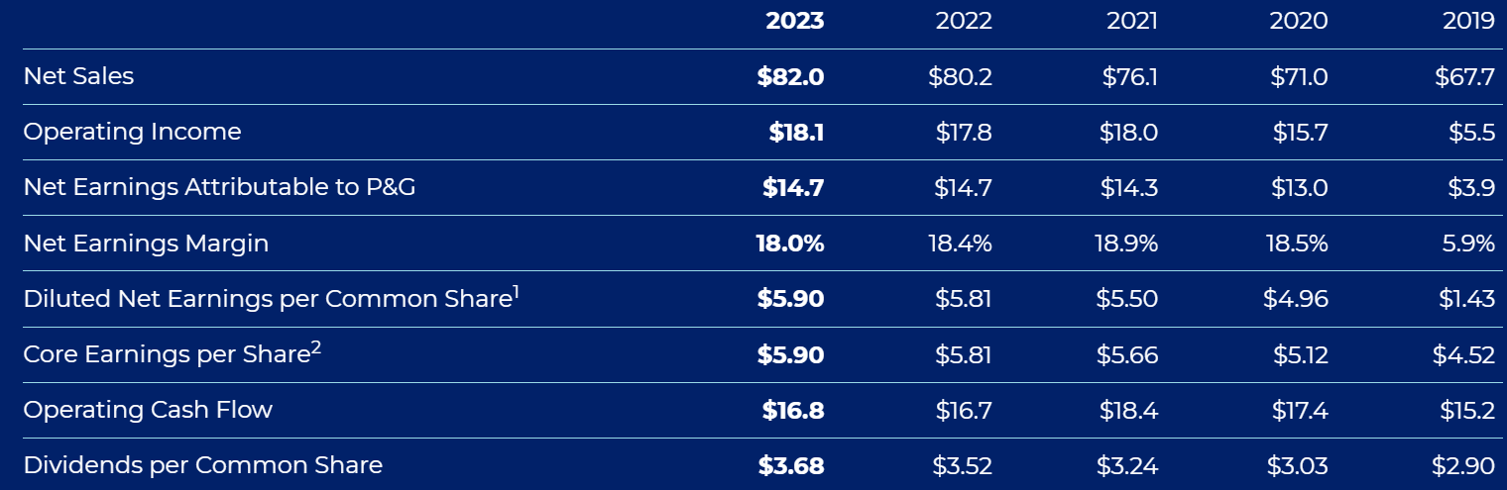

Balance Sheet Strength: P&G maintains a strong balance sheet with manageable levels of debt and ample liquidity. The company's financial stability enables it to weather economic downturns, pursue strategic initiatives, and capitalize on growth opportunities as they arise.

Efficient Capital Allocation: P&G prioritizes capital allocation decisions that maximize shareholder value. The company evaluates investment opportunities based on their potential for long-term growth, profitability, and risk-adjusted returns, while also considering factors such as capital efficiency and return on invested capital (ROIC).

Operational Efficiency: P&G continuously seeks opportunities to enhance operational efficiency and productivity throughout its value chain. The company implements cost-saving initiatives, supply chain optimizations, and organizational efficiencies to improve profitability and maintain competitiveness in the consumer goods market.

COMPARE COMPITATIVE ADVANTAGE OF TWO COMPANIES

*MICROSOFT CORPORATION & THE PRODUCT AND GAMBLE COMPANY:

MICROSOFT CORPORATIN :

Brand Recognition and Reputation:

Microsoft enjoys widespread brand recognition and a strong reputation built over decades as a leading technology company. Its flagship products like Windows, Office, and Xbox are household names globally.

Technological Innovation:

Microsoft is at the forefront of technological innovation, continuously investing in research and development across various areas such as artificial intelligence, cloud computing, quantum computing, and augmented reality/virtual reality.

Its innovative products and services, including Azure cloud platform, Office 365 productivity suite, and Surface hardware lineup, set industry standards and drive growth.

Market Leadership:

Microsoft holds dominant market positions in several key segments. Windows remains the leading operating system for personal computers, while Office 365 is the go-to productivity suite for businesses and individuals.

Azure is a major player in the cloud computing market, competing effectively with rivals like Amazon Web Services (AWS) and Google Cloud Platform (GCP).

Diversified Product Portfolio:

Microsoft offers a diverse portfolio of products and services spanning software, hardware, and cloud computing. This diversification mitigates risks and allows the company to capture revenue from various sources.

Economies of Scale:

Microsoft benefits from economies of scale due to its large customer base, global operations, and extensive distribution network. This allows the company to spread fixed costs over a larger output, resulting in lower average costs per unit.

Integration and Synergy:

Microsoft's ecosystem of products and services offers seamless integration and synergy, enhancing the overall user experience and driving customer loyalty. Compatibility between Windows, Office, and Azure facilitates smooth workflow transitions for users across different devices and platforms.

Financial Strength:

Microsoft maintains a strong financial position with steady revenue growth, healthy profit margins, and strong cash flow generation. Its robust balance sheet provides financial flexibility for investments in innovation, acquisitions, and returning value to shareholders.

Customer Relationships:

Microsoft has strong relationships with enterprise customers, small businesses, educational institutions, and individual consumers. These relationships foster customer loyalty, drive recurring revenue through subscription-based services, and create opportunities for upselling and cross-selling additional products and services.

THR PRODUCT & GAMBLE COMPANY (P&G) :

P&G is committed to continuous innovation in product formulations, packaging, and marketing strategies within the consumer goods industry. The company invests in research and development to develop new products, improve existing offerings, and address consumer needs.

Innovation allows P&G to differentiate its brands from competitors, introduce new features and formulations, and maintain market leadership in key product categories.

Global Presence and Distribution Network:

P&G has a vast global footprint and distribution network, reaching consumers in over 180 countries. The company's extensive distribution network ensures that its products are readily available to consumers across diverse geographic regions.

This widespread presence enables P&G to respond quickly to market trends, adapt to local preferences, and capitalize on emerging opportunities in various markets worldwide.

Customer Insights and Marketing Capabilities:

P&G is renowned for its deep understanding of consumer preferences and effective marketing strategies. The company leverages consumer insights to develop targeted marketing campaigns, product innovations, and branding initiatives.

P&G's marketing capabilities allow it to create emotional connections with consumers, differentiate its brands from competitors, and maintain a strong presence in the highly competitive consumer goods market.

Scale and Efficiency:

P&G benefits from economies of scale due to its large-scale production capabilities and global operations. The company's size allows it to achieve cost efficiencies in sourcing, manufacturing, and distribution, contributing to competitive pricing and profitability.

Scale also provides P&G with bargaining power with suppliers, retailers, and other partners, further enhancing its competitive position in the consumer goods industry.

Supply Chain Management:

P&G has a sophisticated supply chain management system that ensures efficient production, distribution, and inventory management. The company's supply chain capabilities enable it to meet consumer demand, minimize costs, and respond quickly to market fluctuations.

Sustainability Initiatives:

P&G is committed to sustainability across its operations and product lifecycle. The company focuses on reducing its environmental footprint, conserving resources, and promoting social responsibility.

Sustainability initiatives not only align with consumer preferences for eco-friendly products but also contribute to cost savings, risk mitigation, and brand reputation enhancement, giving P&G a competitive advantage in the marketplace.

Assess sustainability:

Microsoft Corporation:

Environmental Initiatives:

Microsoft has made significant commitments to environmental sustainability, aiming to become carbon negative by 2030. It plans to achieve this through carbon reduction, removal, and offset initiatives.

The company has pledged to shift to 100% renewable energy for its global operations and has invested in renewable energy projects to support this goal.

Microsoft is focused on reducing its carbon footprint across its supply chain and product lifecycle, including manufacturing, transportation, and end-of-life recycling.

Social Responsibility:

Microsoft is committed to promoting digital inclusion and accessibility. It offers technology solutions and training programs to empower underserved communities and bridge the digital divide.

The company advocates for diversity, equity, and inclusion (DEI) in its workforce and has implemented initiatives to increase diversity and foster an inclusive workplace culture.

Governance Practices:

Microsoft maintains high standards of corporate governance and transparency. It has clear policies and procedures in place to ensure ethical conduct, compliance with regulations, and accountability to stakeholders.

The company regularly discloses its ESG performance and initiatives in its annual sustainability reports, demonstrating a commitment to transparency and accountability.

The Procter & Gamble Company (P&G):

Environmental Initiatives:

P&G has set ambitious sustainability goals, including reducing greenhouse gas emissions, conserving water, and achieving zero manufacturing waste to landfill in its facilities.

The company focuses on product innovation and packaging sustainability, with initiatives to reduce the environmental impact of its products and increase the use of recycled and renewable materials.

Social Responsibility:

P&G is committed to improving the well-being of communities through various social impact initiatives. These include programs to provide clean drinking water, promote hygiene and sanitation, and support education and economic empowerment.

The company has initiatives to enhance workplace safety, diversity, and inclusion, aiming to create a positive and inclusive work environment for its employees worldwide.

Governance Practices:

P&G maintains robust governance practices, with a commitment to ethical conduct, integrity, and compliance with laws and regulations.

The company has a comprehensive corporate governance framework, including board oversight, risk management processes, and internal controls to ensure accountability and transparency.

Overall Assessment:

Both Microsoft and P&G demonstrate strong commitments to sustainability across their operations, with initiatives addressing environmental impact, social responsibility, and governance practices.

These companies recognize the importance of sustainability in driving long-term value creation, mitigating risks, and meeting stakeholder expectations.

Continuous monitoring, evaluation, and improvement of sustainability performance are essential for both Microsoft and P&G to achieve their sustainability goals and contribute to a more sustainable future.

CONCULSION : Microsoft Corporation: With its leadership in cloud computing, strong brand recognition, and commitment to sustainability, Microsoft presents an attractive investment option. The company's focus on technological innovation, diversified product portfolio, and robust financial performance position it well for long-term growth. Investors seeking exposure to the technology sector with a focus on sustainability may find Microsoft an appealing choice.

The Procter & Gamble Company (P&G): P&G's extensive brand portfolio, global presence, and sustainability initiatives make it an appealing investment opportunity in the consumer goods sector. The company's emphasis on product innovation, social responsibility, and governance practices align well with sustainable investing principles. Investors looking for stability, dividend income, and exposure to consumer staples may consider P&G as part of their portfolio.

Ultimately, both Microsoft and P&G demonstrate strong commitments to sustainability while maintaining competitive positions in their respective industries. Investors should carefully evaluate their investment objectives, risk tolerance, and portfolio diversification strategy before making investment decisions. A balanced approach that considers both financial performance and ESG factors may provide the best long-term returns and align with investors' values and sustainability goals.